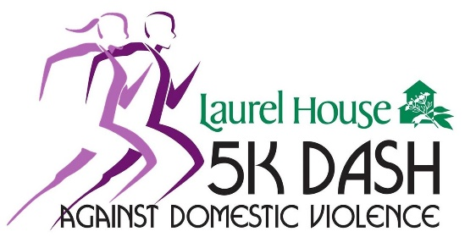
VIRTUAL
Laurel House 5K DASH
Friday, October 15, 2021 – Sunday, October 17, 2021

Laurel House 5K DASH Against Domestic Violence – Sponsorship Opportunities
SPONSORSHIP BENEFITS | Sneaker  $175 | Finish Line  $250 | Medal  $500 | Mile Marker  $750 | Marathon  $1000 | Triathlon  $5000
Verbal name recognition at  Event & personalized virtual event signage |  |  |  |  | X | Benefits may be customized to meet your business needs
Personalized Facebook ad for your company. |  |  |  | X | X
Company recognized on Social Media | X | X | X | X | X
Acknowledgement on  event t-shirt | Company Name | Company Name | Company Logo | Company Logo | Logo prominently placed
Acknowledgement on event webpage | Company Name | Company Name | Company Logo & hyperlink | Company Logo & hyperlink | Logo with hyperlink
Event entries and T-shirts | 1 | 2 | 4 | 6 | 8

Please contact Tina Quinci, Senior Director, at 610-277-1860, ext. 102 or tquinci@laurl-house.org if you wish to customize your sponsorship to meet your business or individual giving needs. While sponsorships will be accepted up until the day of the event, if you would like to take advantage of the benefits isted above your sponsorship must be received by September 3, 2021.

Laurel House is a not-for-profit, tax exempt, charitable organization as defined under the IRS Code Section 501c(3). Tax Exemption ID # 23-2172743. The official registration and financial information of Laurel House may be obtained from PA Dept. of State by calling toll free 1-800-732-0999. Registration does not imply endorsement.
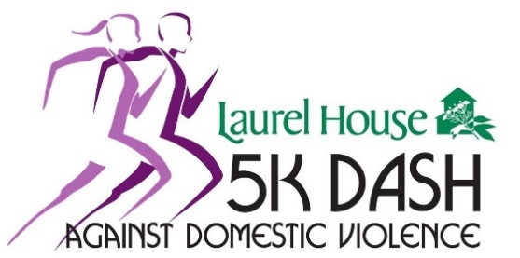
VIRTUAL 2021 Sponsorship Form

Thank you for your interest in sponsoring Laurel House’s 5K DASH Against Domestic Violence. Please fill out this form and return to:
5K DASH, P.O. Box 764, Norristown PA 19404 or email to tquinci@laurel-house.org
Please make checks payable to: Laurel House. Please include in the memo: DASH Sponsorship

Business/Sponsor Name (as it should appear on all materials):

Contact Name:

Address:

City, State & Zip:

Phone: Email:
Please indicate shirt sizes: _________________________________________ Website: _____________________________________________________

Logos must be provided by the sponsors in print-ready eps vector art. Any questions, please contact Tina Quinci at tquinci@laurel-house.org

Sponsorship Level: Triathlon ($5,000) Marathon ($1,000) Mile Marker ($750) Medal ($500) Finish Line ($250) Sneaker ($175)

Payment Information: My payment is enclosed Please charge $ to my (please circle one of the choices below):
Visa MasterCard American Express Discover
Name on Card: Account Number: Exp. Date:

Billing Address: Billing Zip: ____________ CVV:

Laurel House is a not-for-profit, tax exempt, charitable organization as defined under the IRS Code Section 501c (3). Tax Exemption ID # 23-2172743. The official registration and financial information of Laurel House may be obtained from PA Dept. of State by calling toll free 1-800-732-0999. Registration does not imply endorsement.

